PREDICTIVE MAINTENANCE OF AIRCRAFT ENGINES
Abstract
Predictive maintenance is essential in numerous industries, specifically in airline industries.There are abundant applications of predictive maintenance.It provides cost savings due to reduced downtime of the machinery parts,elusion of machinery failure because of connected parts and decreased storage cost for storing spare parts to name a few.Machines can perform predictive maintenance all the time when trained on machine Learning and deep Learning algorithms and can also give automated alerts when irregularities are perceived in the operations.Data which is collected over a period of time called historical data based on aircraft engine failures, is used in the scenarios of predictive maintenance to interpret previous failures.In this paper performances of different algorithms related to machine learning and deep learning are studied and compared,finally an algorithm which gives best results to predict the RUL i.e Remaining Useful Lifetime of the aircraft engine and also which predicts whether an engine fails in a particular time period for an aircraft engine is suggested.In the experimental results of proposed system LSTM outperforms the machine learning algorithms to predict Remaining Useful Lifetime and to classify the status of engine.
Keywords:Predictive maintenance,aircraft engines,deep learning,machine learning, remaining useful lifetime(RUL),engine failure and long short term memory(LSTM).
Introduction
In the past if a mechanic was servicing a machine and found an unusual visual in a certain part and that was exchanged. That is already predictive maintenance.By using smart algorithms this task can be performed by machines and algorithms 24/7. In Machine learning projects firstly the Data is collected overtime to monitor the condition of the equipment.As in most ML projects, there is a need for enough historical data to understand previous failures.The objective is to find patterns that can help to predict and ultimately prevent failures.
Failure prediction is a major topic in predictive maintenance in many industries. Aircrafts are particularly interested in predicting equipment failures in advance so that they can enhance their operations and reduce delays.Observing the engine’s health and condition through sensors and telemetry data is assumed to facilitate this type of maintenance by using machine learning algorithms.one of the Application is Rather than focusing on emergency repairs the maintenance team can focus on long term improvements.
Literature Survey
In [4] the authors proposed various ML algorithms and have evaluated the performances to predict RUL and also to analyze the status of aircraft engines.Predicting RUL is a regression problem and is evaluated on RMSE metric..Methods based on boosting have resulted in high performance [7].By considering weighted combination of more than one classifier,the authors of the paper [7] showed that they can outperform methods based on a single classifier.In recent times CatBoost,LightGBM and XGBoost have gained massive attention in boosting techniques which are based on decision tree.LightGBM has outperformed other boosting techniques in [9].In [8] Support Vector Machine algorithm i.e SVM ,Random Forest algorithm shortly called as RF & k-nearest neighbor ML algorithms are compared among which Random Forest(RF) algorithm surpasses the remaining two of the algorithms.In paper [10] also, the authors have demonstrated that Random Forest surpasses the other algorithms for predicting RUL of aircraft engines in results of their paper.In predictive maintenance applications,the performance of elastic-net has been shown superior when compared with Ridge and LASSO [11].
Several algorithms in machine learning has been implemented and a correlative research of those models has been performed on four datasets in [6].The datasets used are taken from NASA repository.The dataset used in [2] is event logs which is different from data based on historical data of aircraft engines run to failure data in which degradation pattern of engine is reflected in sensor values.In the paper [2] the authors have formulated a problem based on regression to find possibility of occurrence of an event i.e to find RUL of an engine, provided the occurrence of the past event where they have implemented regression based on multiple instance learning along with data wrangling.Along with engines in aircraft industry,medical equipment [17], [18], Hard drives [16] and web servers [19] are some of the application domains.The authors in [20] have used an approach based on genetic algorithms to perform the predictions relying on prediction rules.Multiple instance regression model is appropriate compared to other models to tackle events that have randomly occurred before the failure to positive class.In paper [17] toward this direction the authors have created a positive sample by taking the average features from events close to failure.
In [5], the authors have predicted faults having different priorities as a binary classification problem.For feature extraction they have applied term frequency and inverse frequency.In [3] predictive maintenance of the aircraft engines is a regression problem in which RUL of the engine is predicted by implementing the LSTM,CNN and a combination of LSTM and CNN algorithms.In [13] the authors have proposed an algorithm to predict RUL of aeroengines by implementing a loss function called C-loss function which has achieved best results when compared with ELM algorithms.The authors of paper [14] have implemented an algorithm namely MLP which is a frequently used algorithm to foresee the status of an aircraft engine.
Methodology/Proposed System
System Architecture:

Implementation:
The project objective is to enhance the maintenance operations by applying data science techniques and machine learning algorithms for predicting more accurate maintenance requirements. By considering the aircraft engine’s sensor values over time, the machine learning algorithm can learn the relationship between the changes in sensor values to the historical failures and sensor values in order to predict failures in the future.Some of the parameters in dataset includes:aircraft engine run-to-failure events,operational settings,sensors measurements.
Training data file contains aircraft engines’ run-to-failure data. 20,000+ cycle records for 100 engines. Test data file contains aircraft engines’ operating data without failure events recorded. Remaining cycles for each engine are provided in a separate ground truth data file. Ground truth data file contains the true remaining cycles for each engine in the test data.
Modeling strategies used for predictive maintenance of aircraft engines include (i)Regression Modeling algorithms
Predicting Engine’s Remaining Useful Life (RUL) of the engine.To predict the number of remaining cycles before engine failure.Both linear and non-linear regression models are implemented to predict engine’s RUL.The following machine learning algorithms and their performance metrics were calculated and evaluated namely:
1.LSTM
2. Linear Regression
3.Decision Tree Regression
4.Random Forests.
1.LSTM
Long Short Term Memory networks are a kind of RNN which are capable of learning long-term dependencies. To avoid the long-term dependency problem LSTMs are designed.Remembering information for long periods of time is their behavior, not something they struggle to learn. In LSTM there are four neural network layers interacting in a special way. Cell state is the key to LSTMs. The first step in implementing the LSTM algorithm is data preprocessing by generating label1,label2 and RUL labels where label1 and label2 columns are used for classification problem for predicting engine failure and RUL label is used for regression problem.Next normalization of the cycle column is performed because it is used for training and the considered window size is 50.The constructed LSTM model has two layers with 100 units as the first layer followed by another LSTM layer with 50 units. To control overfitting, dropout is applied after each LSTM layer.Dense output layer is the final layer with single unit and linear activation.
Pic1
2. Linear Regression:
It is a method of analysis that estimates the relationship between one or more independent variables and a dependent variable.The method estimates the relationship by minimizing the sum of the squares in the difference between the observed and predicted values of the dependent variable configured as a straight line or hyperplane.
3.Decision Tree Regression:
It learns in a hierarchical fashion by repeatedly splitting the dataset into separate branches that maximize the information gain of each split. In the regression tree, the value obtained by terminal nodes in the training data is the mean response of observation falling in that region.The branches/edges represent the result of the node.The branches/edges represent the truth/falsity of the statement and make a decision based on that. Decision tree regression observes features of an object and trains a model in the structure of a tree,so that it can predict data in the future to produce meaningful continuous output.
4.Random Forest:
Random Forest method is used for classification, regression and other tasks, which operates by constructing a multitude of decision trees at training time.Outputting the class means prediction of the individual trees.The sklearn module is used for training the random forest regression model, specifically the RandomForestRegressor function.
(ii)Classification Modeling algorithms
To predict if the engine will fail within a specific cycle window or not is determined by binary classification algorithm.Binary classification algorithms are implemented to predict which engines will fail in the current period, e.g. remaining cycles or TTF in the range 0-30 cycles.The following machine learning algorithms and their performance metrics were calculated and evaluated namely:
1.LSTM
2.XGBoost
1.LSTM:
Long Short Term Memory networks are a kind of RNN which are capable of learning long-term dependencies. To avoid the long-term dependency problem LSTMs are designed . Remembering information for long periods of time is their behavior, not something they struggle to learn. In lstm their are four neural network layers interacting in a special way. cell state is the key to LSTMs. The first step is to generate label1,label2 and RUL label. next we Normalized the cycle column because it is also used for training and considered the window size as 50.we constructed a LSTM layer with 100 units as first layer followed by another LSTM layer with 50 units. To control overfitting dropout is applied after each LSTM layer . Dense output layer is final layer with single unit and sigmoid activation.
2.XGBoost:
The first step in implementing the XGBoost algorithm is data preprocessing by generating labels for the training data.This algorithm uses multiple parameters.The overall parameters have been divided into 3 categories:
1.General Parameters: Guide the overall functioning.
2.Booster Parameters Guide the individual booster at each step.
3.Learning Task Parameters Guide the optimization performed.

Results
For predicting Remaining Useful Lifetime(RUL),different algorithms' performance were compared and evaluated on the dataset.So,to predict the remaining useful lifetime,the prime goal is to decrease the error of predicted remaining useful lifetime of an aircraft engine by the ML model when compared with the original value of the RUL.The algorithms were evaluated on their mean absolute error (MAE),a comparison of their performance is in Table I.The residual graphs of linear regression as shown in Fig. 1,random forest as shown in Fig. 2 and decision tree as shown in Fig. 3 are plotted.For LSTM algorithm MAE is plotted against the number of epochs in Fig. 4 and it is observed that as no. of epochs are increasing the error is decreasing.It is noticed that fine results were achieved by the deep learning algorithm LSTM.
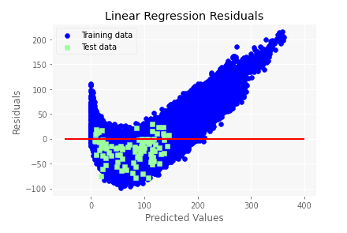
Fig. 1. Residuals plotted for Linear Regression model

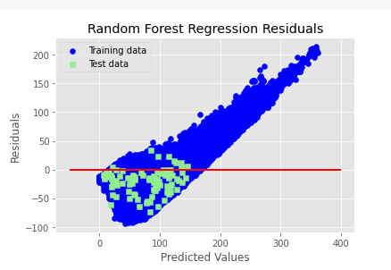
Fig. 2. Residuals plotted for Random Forest model
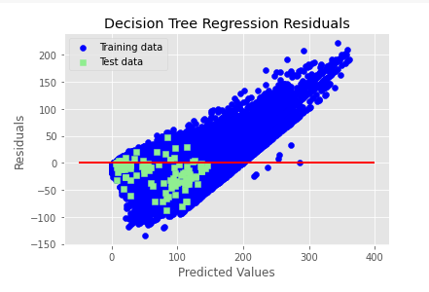
Fig.3. Residuals plotted for Decision Tree model
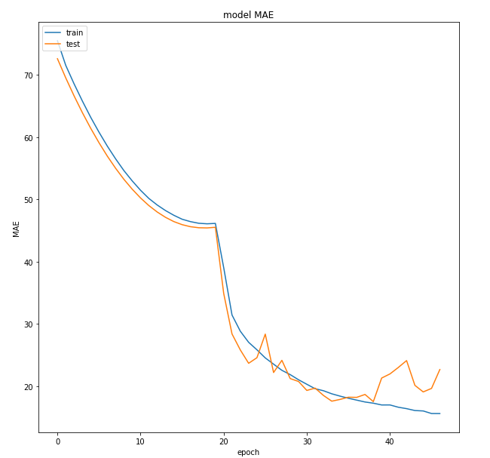
Fig. 4. LSTM model plotted on MAE
TABLE I. PERFORMANCE COMPARISON OF ALL ALGORITHMS
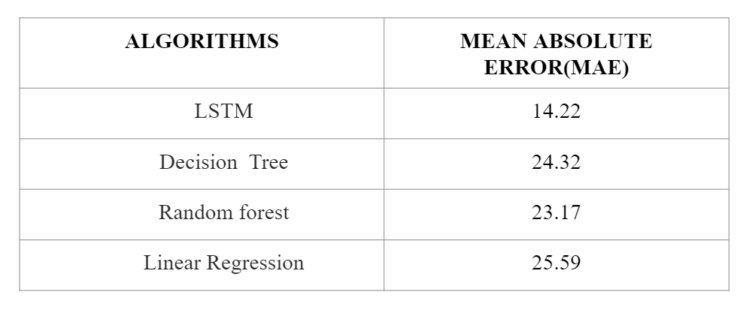

To predict whether an engine fails in a given specific window cycle,two algorithms performance namely LSTM and XGBoost were compared and evaluated on the dataset.The algorithms were evaluated on their accuracy,a comparison of their performance is in Table II.It is noticed that fine results were achieved by the deep learning algorithm LSTM.
TABLE II. PERFORMANCE COMPARISON OF LSTM and XGBoost ALGORITHMS
 | LSTM | XGBoost
Accuracy | 97.84 | 91.01

Conclusion
Predictive Maintenance of Aircraft Engines detects the anomalies and failure patterns and provides early warnings. By applying machine learning algorithms to historical dataset of engines,the project can predict Remaining Useful Life(RUL) and whether an engine fails or not for aircraft engines. Among various algorithms applied on the datasets, Long Short Term Memory(LSTM) has given better results for MAE and accuracy for predicting RUL and engine failure respectively.

References
[1] Yixiang Huang,Peng Li,Chengliang Liu, Pengcheng Xia and Lun Shi,“Fault knowledge transfer assisted ensemble method for remaining useful life prediction,” IEEE Transactions on Industrial Informatics.,vol. 18,no. 3,pp.1758–1769,2021.
[2] Panagiotis Korvesis, Stephane Besseau, and Michalis Vazirgiannis,“Predictive Maintenance in Aviation: Failure Prediction from Post-Flight Reports,” in IEEE 34th International Conference on Data Engineering (ICDE), pp. 1414-1422, 2018.
[3] Hermawan, A. P., Kim, D. S., & Lee, J. M,“Predictive maintenance of aircraft engine using deep learning technique,” in International Conference on Information and Communication Technology Convergence (ICTC), pp. 1296-1298, 2020.
[4] Singh, Deepankar, Mithilesh Kumar, K. V. Arya, and Sunil Kumar,“Aircraft engine reliability analysis using machine learning algorithms,” in IEEE 15th International Conference on Industrial and Information Systems (ICIIS), pp. 443-448. IEEE, 2020.
[5] Weili Yan and Jun-Hong Zhou,“Predictive modeling of aircraft systems failure using term frequency-inverse document frequency and random forest,”in IEEE International Conference on Industrial Engineering and Engineering Management (IEEM), pp. 828-831, 2017.
[6] Vimala Mathew, Tom Toby, Vikram Singh, B. Maheswara Rao, and M.Goutham Kumar,“Prediction of Remaining Useful Lifetime (RUL) of turbofan engine using machine learning,” in IEEE International Conference on Circuits and Systems (ICCS), pp. 306-311. IEEE, 2017.
[7] T. G. Dietterich, “Ensemble methods in machine learning,” pp. 1–15,2000.
[8] N. Amruthnath and T. Gupta, “A research study on unsupervised machine learning algorithms for early fault detection in predictive maintenance,” in 5th International Conference on Industrial Engineering and Applications (ICIEA), IEEE, pp. 355–361,2018.
[9] E. A. Daoud, “Comparison between xgboost, lightgbm and catboost using a home credit dataset,” International Journal of Computer, Electrical, Automation, Control and Information Engineering, vol. 13, no. 1, pp. 6 – 10, 2019.
[10] D. Wu, C. Jennings, J. Terpenny, R. X. Gao, and S. Kumara, “A comparative study on machine learning algorithms for smart manufacturing tool wear prediction using random forests,” American Society of Mechanical Engineers.,vol. 139, no. 7, 2017.
[11] G. A. Susto, A. Schirru, S. Pampuri, and A. Beghi, “A predictive maintenance system based on regularization methods for ion-implantation,” pp. 175–180, May 2012.
[12] A. Altay, O. Ozkan, and G. Kayakutlu, “Prediction of aircraft failure times using artificial neural networks and genetic algorithms,” Journal of Aircraft, vol. 51, pp. 47–53, 02 2014.
[13] B. Zhang, Y. Li, Y. Bai, and Y. Cao, “Aeroengines remaining useful life prediction based on improved c-loss elm,” IEEE Access, vol. 8, pp.49 752–49 764, 2020.
[14] D. Zhang, E. Stewart, J. Ye, M. Entezami, and C. Roberts, “Roller bearing degradation assessment based on a deep mlp convolution neural network considering outlier regions,” IEEE Transactions on Instrumentation and Measurement, vol. 69, no. 6, pp. 2996–3004, 2020.
[15] A. P. Hermawan, R. R. Ginanjar, D. Kim, and J. Lee, “Cnn-based automatic modulation classification for beyond 5g communications,”IEEE Communications Letters, vol. 24, no. 5, pp. 1038–1041, 2020.
[16] J. F. Murray, G. F. Hughes, and K. Kreutz-Delgado, “Machine learning methods for predicting failures in hard drives: A multiple-instance application,” Journal of Machine Learning Research, vol. 6, pp. 783– 816, Dec. 2005.
[17] R. Sipos, D. Fradkin, F. Moerchen, and Z. Wang, “Log-based predictive maintenance,” in Proceedings of the 20th ACM SIGKDD international conference on knowledge discovery and data mining.ACM, pp. 1867–1876,2014.
[18] Y. Yuan, S. Zhou, C. Sievenpiper, K. Mannar, and Y. Zheng, “Event log modeling and analysis for system failure prediction,” IIE Transactions, vol. 43, no. 9, pp. 647–660, 2011.
[19] K. Zhang, J. Xu, M. R. Min, G. Jiang, K. Pelechrinis, and H. Zhang, “Automated system failure prediction: A deep learning approach,” in IEEE International Conference on Big Data,IEEE, pp. 1291– 1300,2016.
[20] G. M. Weiss and H. Hirsh, “Learning to predict rare events in event sequences,” in KDD, pp. 359–363,1998.

